**Machine Learning with Python**

* Download anaconda for python and install
* CDM
  + Pip install jupyter
  + Pip install pandas
  + Pip install scikit-learn
  + Jupytar notebook
    - Opens notebook
* Anaconda
  + Open jupyter
  + Desktop
    - New file
      * Python
* Import Csv
  + Download csv file
  + Save on desktop
* Anaconda
  + Import pandas as pd
  + Df=pd.read_csv(“vg sales”)
    - Df
    - Df.shape = shows how many rows and colums
    - Df.describe() = Breakdown of average, min and max etc.
    - Df.vaues

**Jupyter Cheat sheet**

* A = Creates code above
* B = Create code below
* D,D = Deletes row of code
* Df
  + Press tab
    - Displays all options
    - Press Shift + Tab = gives description
* CTRL + Slash = Auto comments code

**Structure**

1. Import Data
2. Clean the data
3. Split data
4. Create a model
5. Train model
6. Make predictions
7. Evaluate and improve

**Import Data:**

This step involves loading your dataset into the machine-learning environment. You may have data stored in various formats such as CSV files, Excel spreadsheets, or databases.

**Clean the Data:**

Data cleaning involves preparing your dataset for analysis by handling missing values, removing duplicates, correcting data formats, and dealing with any inconsistencies or errors in the data.

**Split Data:**

Splitting the data is necessary to separate it into two subsets: one for training the machine-learning model and the other for evaluating its performance. Typically, the data is divided into a training set and a test set.

**Create a Model:**

Creating a model involves selecting an appropriate machine learning algorithm based on the nature of your data and the problem you are trying to solve. This could be regression, classification, clustering, or other types of algorithms.

**Train Model:**

Training the model means fitting the algorithm to the training data so that it can learn the underlying patterns and relationships. During this process, the model adjusts its parameters to minimize errors and improve its predictive performance.

**Make Predictions:**

Once the model is trained, it can be used to make predictions on new, unseen data. This involves applying the trained model to the test dataset to generate predictions for the target variable.

**Evaluate and Improve:**

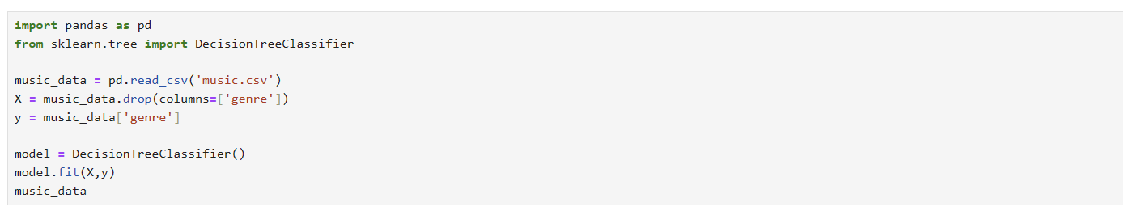Evaluating the model involves assessing its performance using various metrics and techniques. This step helps you understand how well the model is performing and identify areas for improvement. You may need to iterate on the model, adjust hyper parameters, or try different algorithms to improve its accuracy and generalization ability.

